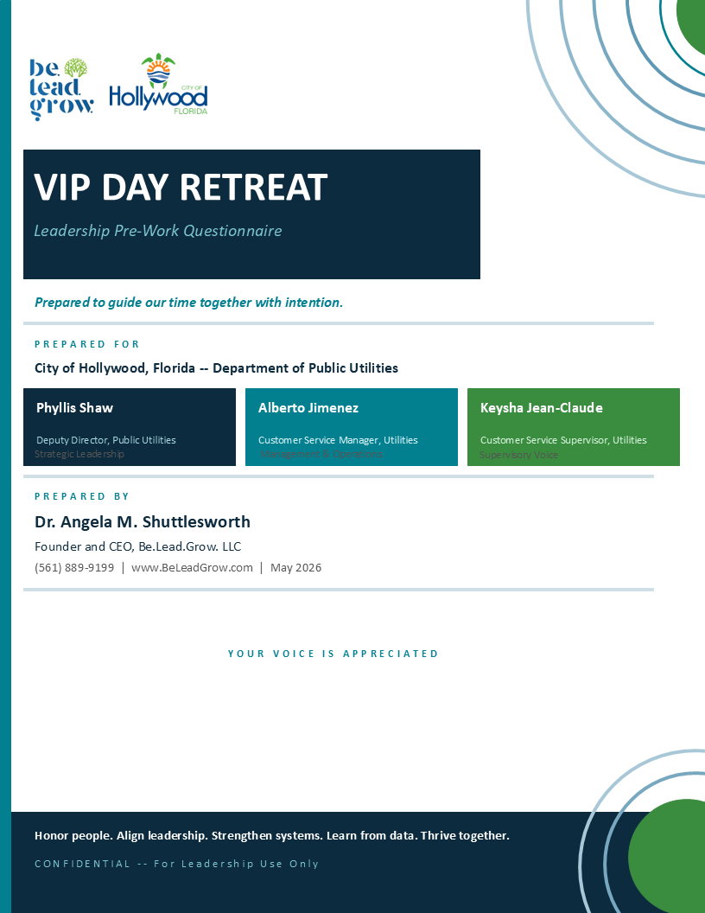

VIP DAY RETREAT
Pre-Work Preparation Questionnaire
City of Hollywood, FL -- Department of Public Utilities | Customer Service Team

This questionnaire is designed to help you prepare for our upcoming VIP Day. As mentioned during our recent call, there are no wrong answers. We are gathering what you know, what you can find, and what may need to come from your system vendor. Please complete as much as you can and note where data is not readily available. Your honest responses make our time together more effective and your outcomes more durable.

Instructions for Filing and Collaboration
1. This document is shared digitally so that all three leaders can contribute to it together. Please save it in a shared folder that Phyllis Shaw, Alberto Jimenez, and Keysha Jean-Claude can all access and edit.
2. For each question that asks you to locate or reference a document, please paste the file link or path directly in your response so that Dr. Shuttlesworth can access it for review before the VIP Day.
3. This document is provided in Word format intentionally. You are not limited by the space provided. Please expand any response field as needed to capture the full picture.
4. The Billing Manager may attend select portions of the VIP Day. If any question is most accurately answered by the Billing Manager, please note that in your response and flag it for follow-up.

Please complete and return at least 5 business days before the VIP Day date. If a question is not applicable or the data is unavailable, simply note that as it is still valuable information.
Thanks in advance for the time and energy spent completing this document. It will surely help us better understand and support you during the VIP Day, and beyond.

SECTION 1 -- PHONE SYSTEM OVERVIEW AND DATA AVAILABILITY
HEALTHY Connection: T -- THRIVE with Efficiency and Passion | A -- ADVANCE the Culture with Innovation

This section focuses on your current phone system. We are noting how it works, who supports it, and what data it captures. We are also interested in understanding how your phone system and billing or operations systems communicate with each other, since that integration (or the absence of it) directly shapes what your team can and cannot do in real time.

1A. Phone System Overview
1. | What is the name and version of your current phone system? If the billing system is separate, please note that as well.
2. | Who is your primary contact at the phone system vendor? Please provide their name, title, and contact information. Are there regularly scheduled calls or check-ins with this contact? If so, when is the next one scheduled?
3. | How long has this phone system been in use at the City of Hollywood? If this is a newer system, was there a reason for the transition from the previous system?
4. | Are there any known limitations of the current phone system that directly impact your team's ability to serve residents?
5. | Is there a system administrator or internal technical contact who manages phone system access, reporting, or vendor communication?
6. | How does your phone system communicate with your billing management system, if at all? For example, can a CSR see account information while on a call, or do they need to navigate to a separate system? Please describe how these systems do or do not work together.

1B. Data Availability -- Please Check All That Apply
For each data type below, indicate whether it is: (A) Readily available in the system, (B) Available but requires a report request, or (C) Not available -- must be requested from vendor.

Data Type | (A) In System / Easy Pull | (B) Requires Report Request | (C) Vendor Request Needed
Total call volume (daily / weekly / monthly)
Calls by type or reason for contact
Average call handle time
Call abandon rate
Escalation rate (calls moved to supervisor)
Number of accounts on payment plan
Number of disconnections per month
Number of reconnections per month
Estimated vs. actual meter readings ratio
Back-billing incidents per month
Number of new accounts opened per month
Accounts with 30-plus day past due balance
Resident complaints submitted by non-phone channel
Positive feedback or compliments received
Work orders generated from CS calls

1C. Vendor Data Requests
7. | Is there a formal process to request custom reports or data exports from your phone system vendor? If yes, what is the process and typical turnaround time?
8. | Are there any data requests you have already submitted to the vendor that are currently pending? If so, what are they?
9. | Have any data requests been answered and fulfilled by the vendor in the past? If yes, please share examples of those reports or provide file links so we can review them before the VIP Day.
10. | What data would you most like to have access to on an ongoing basis that you currently cannot easily retrieve?

SECTION 2 -- CALL VOLUME AND TOP ISSUES
HEALTHY Connection: H -- HEAR with the Intention to Act | T -- THRIVE with Efficiency and Passion

This section helps us understand the volume and nature of resident contacts so we can develop a meaningful reporting framework and identify where scripting, training, or system improvements will have the greatest impact.

2A. Call Volume
11. | What is the approximate average number of calls your team receives per day?
12. | Are there specific days of the week or times of the month when call volume is significantly higher?
13. | How many Customer Service Representatives are typically available to answer calls on a given day?
14. | How are calls currently tracked? Is there a ticketing system, a call log, or another method?
15. | During training, a suggestion was made about pre-tracking -- allowing customers to identify their reason for calling and be directed to a designated queue before speaking to a representative. Is that feature currently available in your phone system? If yes, is it operationalized? If not, what would be required to activate or build it?

2B. Top Resident Issues
Please rank the following as: (1) Very Common, (2) Occasional, (3) Rare, or (4) Not Applicable. Add any unlisted issues at the bottom.

Issue / Reason for Contact | Very Common | Occasional | Rare | N/A
Questions about high water bill | ☐ | ☐ | ☐ | ☐
Estimated vs. actual meter reading dispute | ☐ | ☐ | ☐ | ☐
Back-billing or catch-up billing complaint | ☐ | ☐ | ☐ | ☐
Request for payment plan or extension | ☐ | ☐ | ☐ | ☐
Disconnection notice or service shutoff | ☐ | ☐ | ☐ | ☐
Reconnection after shutoff | ☐ | ☐ | ☐ | ☐
New service or account setup | ☐ | ☐ | ☐ | ☐
Billing error or adjustment request | ☐ | ☐ | ☐ | ☐
Account not found or ID issues | ☐ | ☐ | ☐ | ☐
Complaint about a field technician | ☐ | ☐ | ☐ | ☐
Escalation to supervisor or commissioner | ☐ | ☐ | ☐ | ☐
Request to speak to someone in person | ☐ | ☐ | ☐ | ☐
Questions about the leak adjustment process | ☐ | ☐ | ☐ | ☐
Confusion about bill format or charges | ☐ | ☐ | ☐ | ☐
Language barrier or translation needed | ☐ | ☐ | ☐ | ☐
Other (write in): | ☐ | ☐ | ☐ | ☐
Other (write in): | ☐ | ☐ | ☐ | ☐

SECTION 3 -- OPERATIONAL FLOW: THE WEEKLY AND MONTHLY RHYTHM
HEALTHY Connection: T -- THRIVE with Efficiency and Passion | E -- ESTABLISH Excellence as Your Norm

Understanding your team's weekly and monthly operational rhythm is essential. Identifying certain tasks such as disconnections, billing runs, new meter installations, and understanding predictable schedules. When CSRs know what is coming, they can prepare for the spike in calls and issues it creates. This section maps that rhythm so we can build it into your operating plan.

3A. Weekly Schedule -- Day-by-Day Flow
Please describe what typically happens on each day of the week from an operational standpoint. For weekdays, describe what your CS team is doing and what other departments are doing that impacts your call volume. For the weekend, we want to understand what happens while your team is not available, alongside what could.

Monday
What is your CS team doing? | What is happening in other departments that impacts you?

Tuesday
What is your CS team doing? | What is happening in other departments that impacts you?

Wednesday
What is your CS team doing? | What is happening in other departments that impacts you?

Thursday
What is your CS team doing? | What is happening in other departments that impacts you?

Friday
What is your CS team doing? | What is happening in other departments that impacts you?

Weekend -- Saturday and Sunday
The following two questions focus on weekend operations as they relate to your team's Monday readiness. Please answer as completely as you can, even if your team does not work weekends.

Saturday and Sunday
What functions from other departments occur on this day that impact your team? | If the City were open and contractors could work on this day, what functions could they perform that would help start the following week more smoothly for your team?

3B. Monthly Cycles
16. | When does your billing cycle run?
17. | When do disconnections typically occur? Is there a specific day or week of the month?
18. | When do reconnections typically happen, and how long does the process take from customer request to service restored?
19. | Are there any other monthly events that predictably impact call volume?
20. | How far in advance does your team typically learn about upcoming events that will generate a significant increase in calls?

3C. Preparedness, Communication, and Supervision
21. | Is there a current process for briefing CSRs before high-volume or high-complexity call periods?  Note: e.g., morning huddles, supervisor notes, team messages, etc.
22. | When a new policy, system change, or billing issue affects residents, how does that information reach your CSRs?  Note: How quickly? Through what channels?
23. | When do formal team meetings currently take place -- both as a group and individually with each representative? Please describe the structure and purpose of those sessions, including whether they include space for guidance, performance support, and addressing issues if they arise.
24. | Given that scripts are not currently in use, which areas of customer interaction do you feel most need a scripted or structured response? Have any scripts or talking points been attempted or drafted since the training discussion? If not, which 3 to 5 areas would you propose as the best starting points?
25. | If a CSR does not know the answer to a resident's question, what is the current process for finding the right answer or escalating?
25B. | During training, the concept of a shared database of standard answers and a data lexicon was introduced (a resource CSRs could reference quickly during a call.) Has any progress been made toward building this? If not, what would need to happen to get it started?

SECTION 4 -- INTERDEPARTMENTAL IMPACT AND WORKFLOWS
HEALTHY Connection: A -- ADVANCE the Culture with Innovation | L -- LEAD with Vulnerability and Joy

The training and team feedback surfaced clear evidence that customer service outcomes are shaped by decisions and processes in other departments. This section maps those interdependencies.

4A. Department Interactions
26. | Which departments does your CS team interact with most frequently in order to resolve a customer issue?  Note: e.g., AMI / Meter Shop, Billing, Field Operations, Accounting, etc.
27. | For each department named above, what is the typical turnaround time for a response or resolution when your team reaches out?  Please Note any departments where the turnaround is a known challenge.
28. | Are there specific handoff processes or workflows that are currently undocumented or inconsistently followed?  For Example: We email Field Ops but don't always hear back, we just figure it out.
29. | What is the one interdepartmental process that, if improved, would most immediately reduce call volume for your team?

4B. The Resident Experience of the Process
30. | From the resident's perspective, what does a successful resolution look like? What are they most satisfied by when they hang up?
31. | What is the most common thing residents misunderstand about how the billing or service process works, and why do you think that misunderstanding keeps recurring?
32. | When a resident escalates their concern to a commissioner or the Mayor's office, what is the typical reason? What could have prevented it at the CSR level?

SECTION 5 -- COMMUNITY RESOURCES AND FINANCIAL RELIEF
HEALTHY Connection: H -- HONOR Everyone's Journey | H -- HEAR with the Intention to Act

Many residents who contact your team are calling in a moment of stress, facing a bill they did not expect, a disconnection they cannot afford to address, or a situation that has built up over time. This section helps us understand what resources currently exist to support those residents, and where there may be an opportunity to do more.

33. | Does your department currently provide information to residents about organizations that offer financial relief, such as utility assistance programs, emergency aid organizations, or local nonprofits, when residents call and discuss their inability to pay?
34. | If your team does not currently provide this type of referral, is there anything in current policy that states you cannot? If a policy exists, please provide a copy of the relevant section or a link to the document.
35. | Are CSRs comfortable discussing financial hardship with residents, or is that typically escalated to a supervisor? What is the current expectation?  Please Note: this discussion with elders was noted in several surveys and during each training.

SECTION 6 -- EMPLOYEE ORIENTATION AND ONBOARDING
HEALTHY Connection: H -- HONOR Everyone's Journey | E -- ESTABLISH Excellence as Your Norm

This section is foundational for long-term sustainability. What you build during the VIP Day should eventually live in how you onboard every new team member. Understanding the current process, and its gaps, allows us to design recommendations that protect the investment you are making now.

6A. Current Onboarding Process
36. | When a new CSR or Billing team member is hired, what does their first day look like?  Note: Walk us through as much detail as you can, who greets them, what they are shown, what they receive, and what is expected of them.
37. | How long does it typically take before a new employee is handling calls independently?  Note: What does that progression look like?
38. | Is there a formal onboarding checklist, guide, or manual currently in use? If yes, please share a copy or provide a file link for review.
39. | Who is primarily responsible for onboarding new team members?  (e.g., Supervisor, Manager, a designated buddy/mentor, HR)
40. | What do new employees typically say they wish they had known sooner?  NOTE: If you have not asked them directly, what do you think they would say?

6B. System and Process Training
41. | Is there a formal training process for the phone system and billing system? Is it live-led, self-paced, or vendor-delivered?
42. | How long does system training typically take before a new employee can navigate it independently?
43. | Are there any system features or processes that even experienced staff find confusing or inconsistently applied?
44. | Is there any reference material (cheat sheets, SOPs, or how-to guides) that staff use for common tasks? If yes, please share copies or provide file links.

6C. Quality Assurance and Performance Review During Onboarding
45. | What form of testing, quality assurance, or performance review is conducted with new employees during their onboarding period?  For example, are calls reviewed at specific intervals -- such as day 7, day 22, or day 30? If there is a formal review structure, please describe it.
46. | At what point does a new employee's performance get formally documented or reviewed for the first time?

6D. Orientation Gaps and Opportunities
47. | What is the most significant gap in your current onboarding process?  What do new employees often get wrong in their first 90 days that experienced staff rarely do?
48. | Is customer service philosophy or communication standards covered during onboarding? If yes, describe how.  For example, “We tell them to be polite' vs. 'We have a documented communication approach'
49. | If you could redesign onboarding from scratch with no constraints, what would the first 30 days look like?  Note: Dream a little. What would set a new employee up for real success?

SECTION 7 -- TEAM VOICE AND OPEN REFLECTION
HEALTHY Connection: H -- HEAR with the Intention to Act | Y -- YIELD to the Awesomeness of YOU

These final questions are intentionally open. They invite each leader to share context, concerns, or ideas that may not fit neatly into the sections above. Each question includes space for all three leaders to respond individually, because your three perspectives together will give us the most complete picture of where you are and where you want to go. This is your space.

50. | What is the one thing you most want to accomplish during the VIP Day?  Phyllis Shaw, Deputy Director:  Alberto Jimenez, Customer Service Manager:  Keysha Jean-Claude, Customer Service Supervisor:

51. | What is the one thing you are most concerned about going into the VIP Day?  Phyllis Shaw, Deputy Director:  Alberto Jimenez, Customer Service Manager:  Keysha Jean-Claude, Customer Service Supervisor:

52. | What is a question you keep asking yourself about your team or your operations that you do not yet have a good answer to?  Phyllis Shaw, Deputy Director:  Alberto Jimenez, Customer Service Manager:  Keysha Jean-Claude, Customer Service Supervisor:

53. | Is there anything about the team's experience, the system, or the department's context that you want Dr. Shuttlesworth to understand before she arrives?  Phyllis Shaw, Deputy Director:  Alberto Jimenez, Customer Service Manager:  Keysha Jean-Claude, Customer Service Supervisor:

54. | Is there anything you are not yet ready to discuss or act on during the VIP Day? It is important to name this upfront so we can honor where you are, boundaries included.  Naming a boundary here does not exclude it from the work. It simply helps us sequence the conversation with care.  Phyllis Shaw, Deputy Director:  Alberto Jimenez, Customer Service Manager:  Keysha Jean-Claude, Customer Service Supervisor:

What you share here matters.
The VIP Day is only as powerful as the honesty brought into the room. Your responses give us a complete view of where you are and what is needed -- and that is how real change begins. Thank you for your time and thoughtfulness. It is appreciated.

Return completed questionnaire to: Dr. Angela M. Shuttlesworth | DrAMS@BeLeadGrow.com I For questions you desire to discuss via text or phone: (561) 889-9199 | www.BeLeadGrow.com

ADDITIONAL NOTES:



